How do Service Companies work like Servicing power or Equipment?

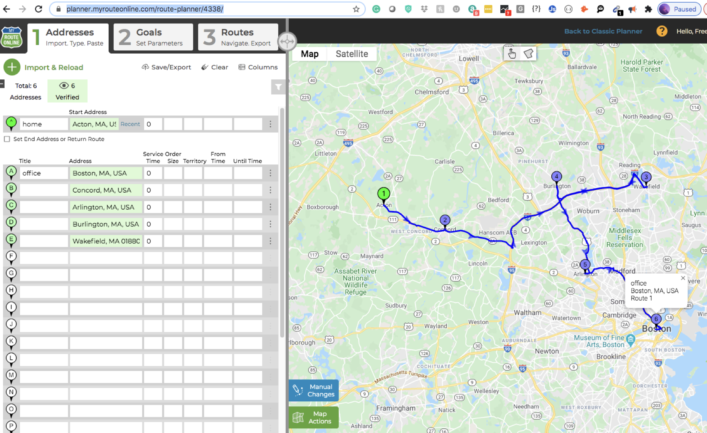

**https://planner.myrouteonline.com/route-planner/4338/**